- What is the total spend per country?

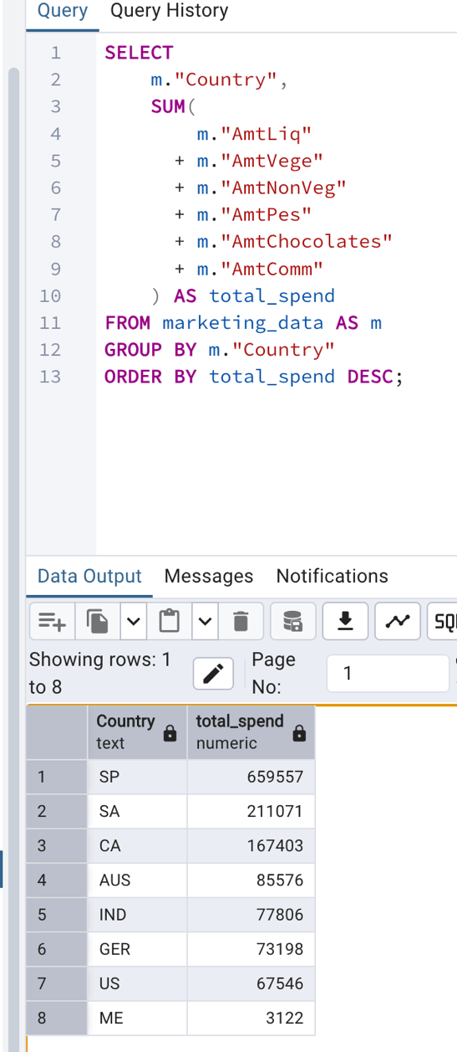
- What is the total spend per product per country?
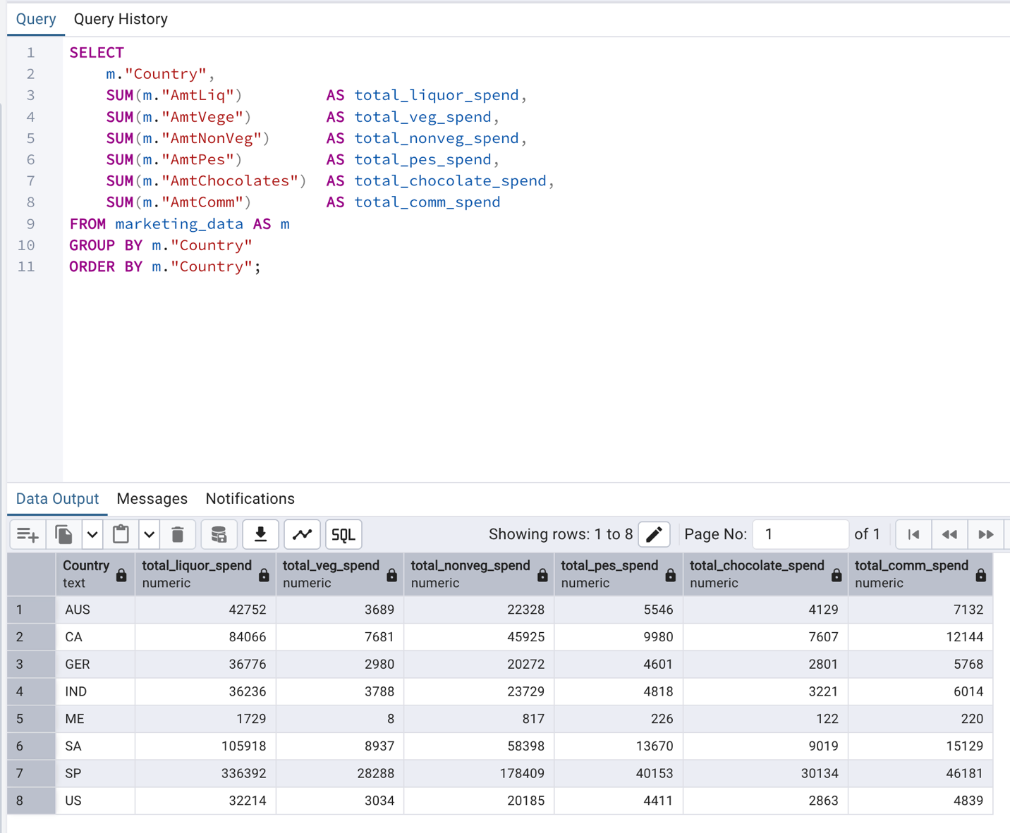
- Which products are the most popular in each country?
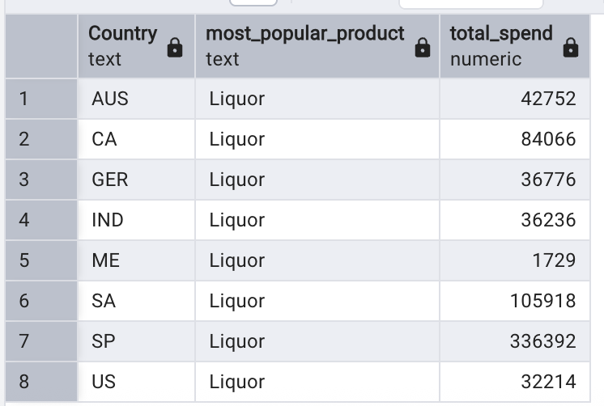
WITH product_spend AS (
SELECT "Country", 'Liquor' AS product, SUM("AmtLiq") AS total_spend
FROM marketing_data
GROUP BY "Country"

UNION ALL
SELECT "Country", 'Vegetables', SUM("AmtVege")
FROM marketing_data
GROUP BY "Country"

UNION ALL
SELECT "Country", 'NonVegetables', SUM("AmtNonVeg")
FROM marketing_data
GROUP BY "Country"

UNION ALL
SELECT "Country", 'Fish', SUM("AmtPes")
FROM marketing_data
GROUP BY "Country"

UNION ALL
SELECT "Country", 'Chocolates', SUM("AmtChocolates")
FROM marketing_data
GROUP BY "Country"

UNION ALL
SELECT "Country", 'Commodities', SUM("AmtComm")
FROM marketing_data
GROUP BY "Country"
),
ranked_products AS (
SELECT
"Country",
product,
total_spend,
ROW_NUMBER() OVER (
PARTITION BY "Country"
ORDER BY total_spend DESC
) AS rn
FROM product_spend
)
SELECT
"Country",
product AS most_popular_product,
total_spend
FROM ranked_products
WHERE rn = 1
ORDER BY "Country";

Which products are most popular based on marital status
- highest total revenue per product, grouped by marital status
- first the total revenue per product
-- highest total revenue per product, grouped by marital status
SELECT
marketing_data."Marital_Status",
SUM("AmtLiq") AS total_revenue_liquor,
SUM("AmtVege") AS total_revenue_vege,
SUM("AmtNonVeg") AS total_revenue_non_veg,
SUM("AmtPes") AS total_revenue_fish,
SUM("AmtChocolates") AS total_revenue_chocolated,
SUM("AmtComm") AS total_revenue_comm
FROM
marketing_data
GROUP BY
"Marital_Status";
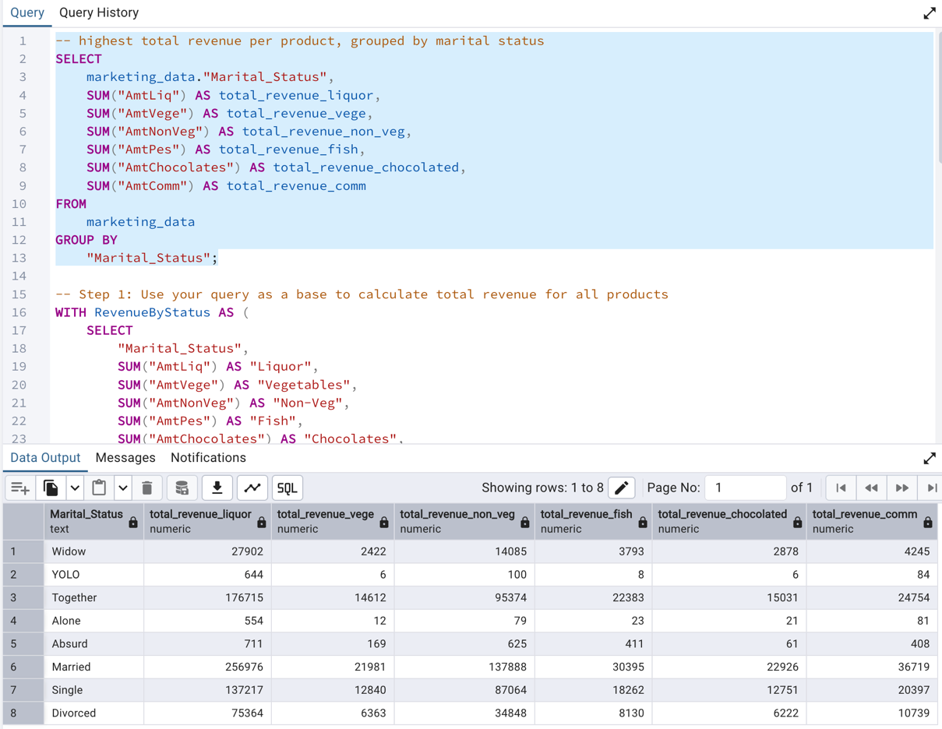
- and now the highest revenue product grouped by marital status
-- Step 1: Use your query as a base to calculate total revenue for all products
WITH RevenueByStatus AS (
SELECT
"Marital_Status",
SUM("AmtLiq") AS "Liquor",
SUM("AmtVege") AS "Vegetables",
SUM("AmtNonVeg") AS "Non-Veg",
SUM("AmtPes") AS "Fish",
SUM("AmtChocolates") AS "Chocolates",
SUM("AmtComm") AS "Commodities"
FROM
marketing_data
GROUP BY
"Marital_Status"
),

-- Step 2: Unpivot the data to compare products within each group
UnpivotedRevenue AS (
SELECT "Marital_Status", 'Liquor' AS product_category, "Liquor" AS revenue FROM RevenueByStatus
UNION ALL
SELECT "Marital_Status", 'Vegetables' AS product_category, "Vegetables" AS revenue FROM RevenueByStatus
UNION ALL
SELECT "Marital_Status", 'Non-Veg' AS product_category, "Non-Veg" AS revenue FROM RevenueByStatus
UNION ALL
SELECT "Marital_Status", 'Fish' AS product_category, "Fish" AS revenue FROM RevenueByStatus
UNION ALL
SELECT "Marital_Status", 'Chocolates' AS product_category, "Chocolates" AS revenue FROM RevenueByStatus
UNION ALL
SELECT "Marital_Status", 'Commodities' AS product_category, "Commodities" AS revenue FROM RevenueByStatus
),

-- Step 3: Rank the products for each marital status by revenue
RankedRevenue AS (
SELECT
"Marital_Status",
product_category,
revenue,
ROW_NUMBER() OVER(PARTITION BY "Marital_Status" ORDER BY revenue DESC) as rank_num
FROM
UnpivotedRevenue
)

-- Step 4: Select only the top-ranked product for each status
SELECT
"Marital_Status",
product_category AS top_product_by_revenue,
revenue AS highest_revenue
FROM
RankedRevenue
WHERE
rank_num = 1;

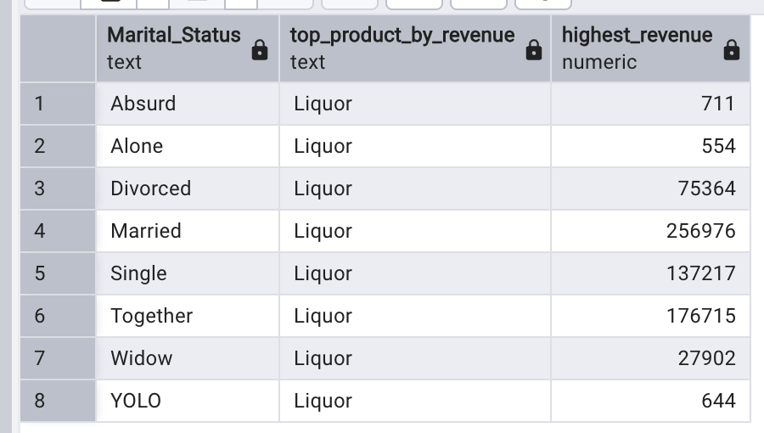

- highest number of customers who made a purchase on a product (product with the most buyers), grouped by marital status
- first, the total number of customers who made a purchase for each product grouped by marital status
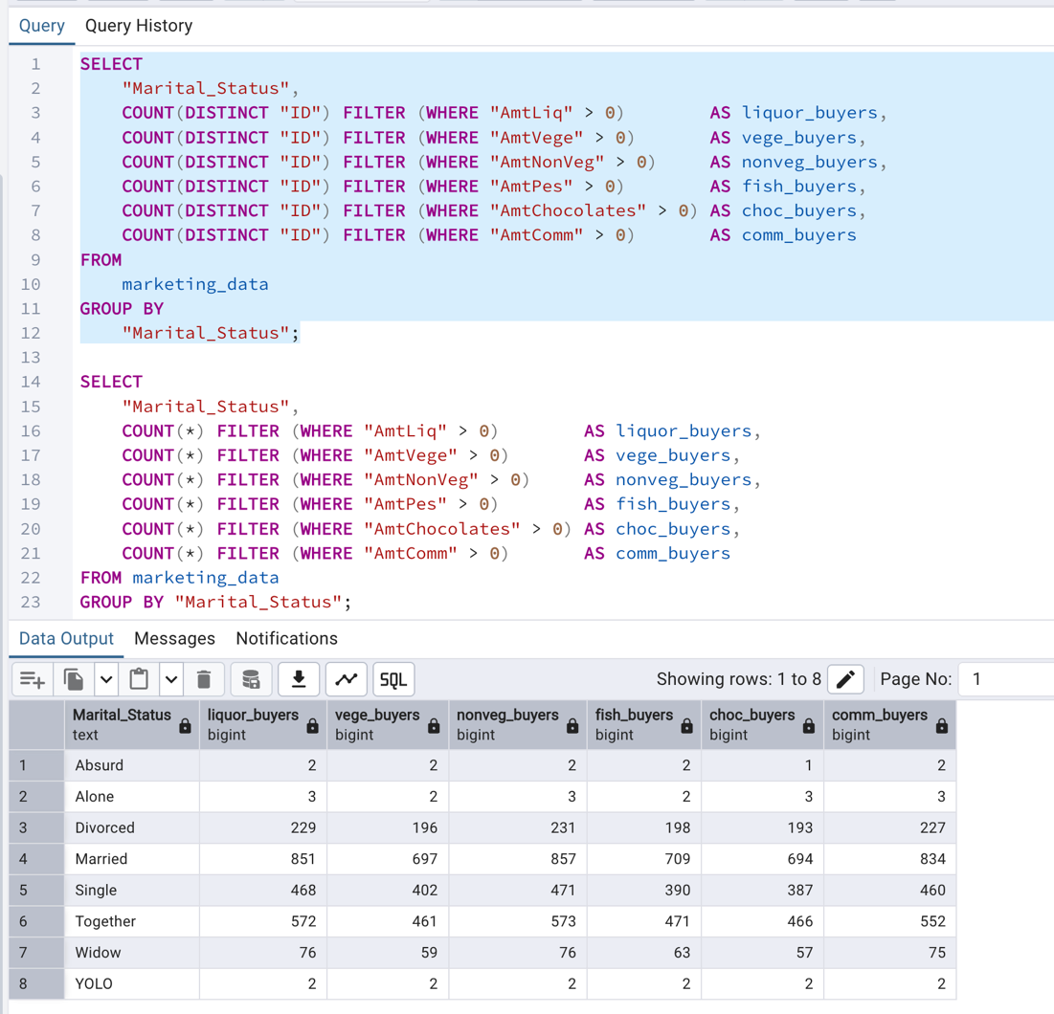

- each product and which one has the most buyers
-- Step 1: Use your query as a base to calculate buyer counts for all products
WITH BuyerCounts AS (
SELECT
"Marital_Status",
COUNT(*) FILTER (WHERE "AmtLiq" > 0) AS "Liquor",
COUNT(*) FILTER (WHERE "AmtVege" > 0) AS "Vegetables",
COUNT(*) FILTER (WHERE "AmtNonVeg" > 0) AS "Non-Veg",
COUNT(*) FILTER (WHERE "AmtPes" > 0) AS "Fish",
COUNT(*) FILTER (WHERE "AmtChocolates" > 0) AS "Chocolates",
COUNT(*) FILTER (WHERE "AmtComm" > 0) AS "Commodities"
FROM
marketing_data
GROUP BY
"Marital_Status"
),

-- Step 2: Unpivot the data to compare products within each group
UnpivotedCounts AS (
SELECT "Marital_Status", 'Liquor' AS product_category, "Liquor" AS buyer_count FROM BuyerCounts
UNION ALL
SELECT "Marital_Status", 'Vegetables' AS product_category, "Vegetables" AS buyer_count FROM BuyerCounts
UNION ALL
SELECT "Marital_Status", 'Non-Veg' AS product_category, "Non-Veg" AS buyer_count FROM BuyerCounts
UNION ALL
SELECT "Marital_Status", 'Fish' AS product_category, "Fish" AS buyer_count FROM BuyerCounts
UNION ALL
SELECT "Marital_Status", 'Chocolates' AS product_category, "Chocolates" AS buyer_count FROM BuyerCounts
UNION ALL
SELECT "Marital_Status", 'Commodities' AS product_category, "Commodities" AS buyer_count FROM BuyerCounts
),

-- Step 3: Rank the products for each marital status by buyer count
RankedCounts AS (
SELECT
"Marital_Status",
product_category,
buyer_count,
ROW_NUMBER() OVER(PARTITION BY "Marital_Status" ORDER BY buyer_count DESC) as rank_num
FROM
UnpivotedCounts
)

-- Step 4: Select only the top-ranked product for each status
SELECT
"Marital_Status",
product_category AS top_product_by_buyers,
buyer_count AS highest_buyer_count
FROM
RankedCounts
WHERE
rank_num = 1;
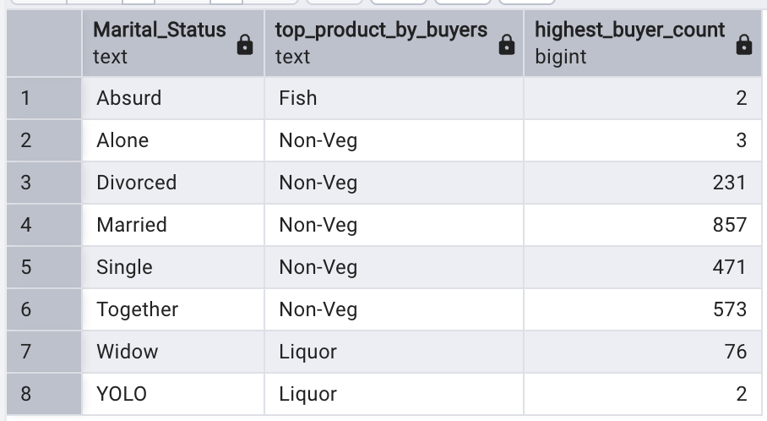

- highest average of total revenue for a product, grouped by marital status
- first, the average total revenue per product grouped by marital status
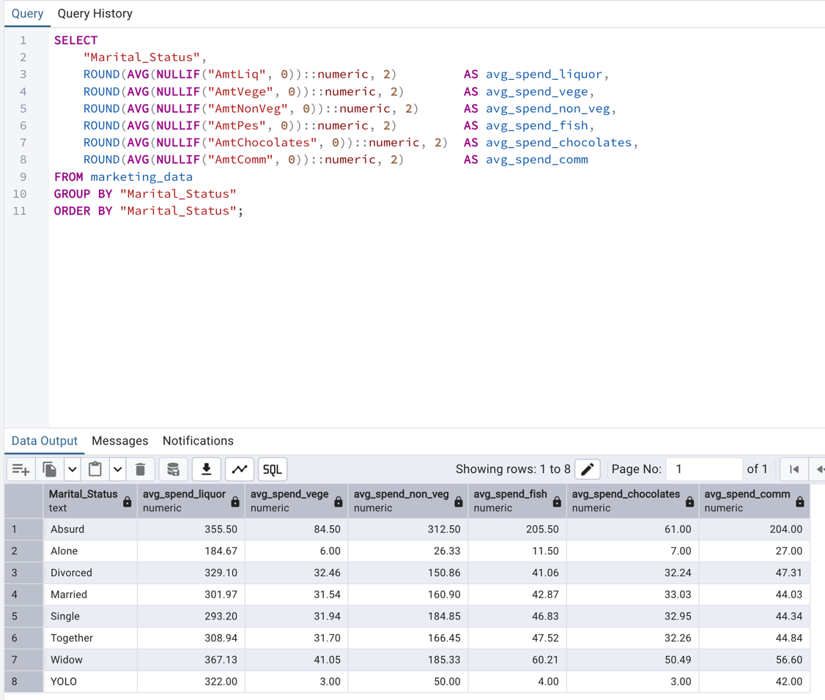
- now the highest average spend per product grouped by marital status
WITH average_spends AS (
SELECT
"Marital_Status",
AVG(NULLIF("AmtLiq", 0)) AS liquor,
AVG(NULLIF("AmtVege", 0)) AS vegetables,
AVG(NULLIF("AmtNonVeg", 0)) AS non_veg,
AVG(NULLIF("AmtPes", 0)) AS fish,
AVG(NULLIF("AmtChocolates", 0)) AS chocolates,
AVG(NULLIF("AmtComm", 0)) AS commodities
FROM marketing_data
GROUP BY "Marital_Status"
),
unpivoted AS (
SELECT "Marital_Status", 'Liquor' AS product_category, liquor AS avg_spend FROM average_spends
UNION ALL
SELECT "Marital_Status", 'Vegetables', vegetables FROM average_spends
UNION ALL
SELECT "Marital_Status", 'Non-Veg', non_veg FROM average_spends
UNION ALL
SELECT "Marital_Status", 'Fish', fish FROM average_spends
UNION ALL
SELECT "Marital_Status", 'Chocolates', chocolates FROM average_spends
UNION ALL
SELECT "Marital_Status", 'Commodities', commodities FROM average_spends
),
ranked AS (
SELECT
"Marital_Status",
product_category,
avg_spend,
ROW_NUMBER() OVER (
PARTITION BY "Marital_Status"
ORDER BY avg_spend DESC NULLS LAST
) AS rn
FROM unpivoted
)
SELECT
"Marital_Status",
product_category AS top_product_by_avg_spend,
ROUND(avg_spend::numeric, 2) AS highest_avg_spend
FROM ranked
WHERE rn = 1
ORDER BY "Marital_Status";
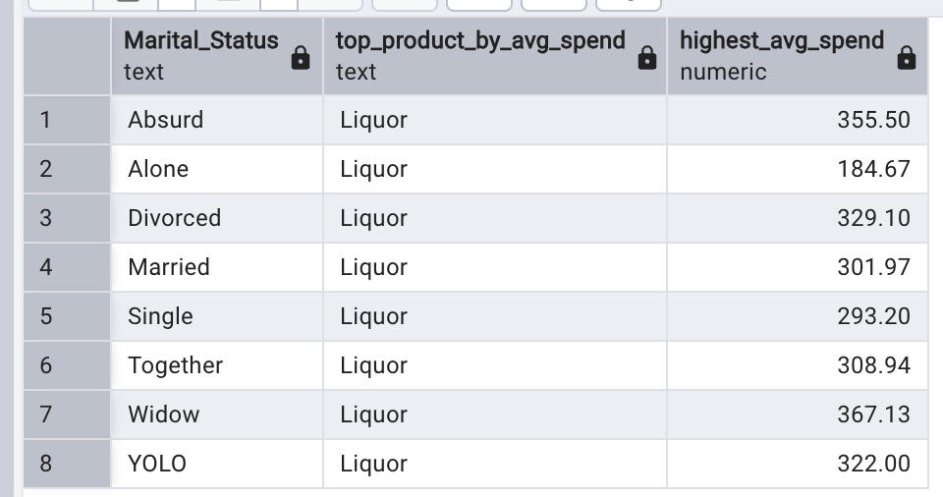

Which products are the most popular based on whether or not there are children or teens in the home?
WITH household_groups AS (
SELECT
CASE
WHEN "Kidhome" = 0 AND "Teenhome" = 0
THEN 'No children or teens'
ELSE 'Children or teens present'
END AS household_type,
"AmtLiq", "AmtVege", "AmtNonVeg", "AmtPes", "AmtChocolates", "AmtComm"
FROM marketing_data
),
averages AS (
SELECT
household_type,
AVG(NULLIF("AmtLiq", 0)) AS liquor,
AVG(NULLIF("AmtVege", 0)) AS vegetables,
AVG(NULLIF("AmtNonVeg", 0)) AS non_veg,
AVG(NULLIF("AmtPes", 0)) AS fish,
AVG(NULLIF("AmtChocolates", 0)) AS chocolates,
AVG(NULLIF("AmtComm", 0)) AS commodities
FROM household_groups
GROUP BY household_type
),
unpivoted AS (
SELECT household_type, 'Liquor' AS product, liquor AS avg_spend FROM averages
UNION ALL SELECT household_type, 'Vegetables', vegetables FROM averages
UNION ALL SELECT household_type, 'Non-Veg', non_veg FROM averages
UNION ALL SELECT household_type, 'Fish', fish FROM averages
UNION ALL SELECT household_type, 'Chocolates', chocolates FROM averages
UNION ALL SELECT household_type, 'Commodities', commodities FROM averages
),
ranked AS (
SELECT
household_type,
product,
avg_spend,
ROW_NUMBER() OVER (
PARTITION BY household_type
ORDER BY avg_spend DESC NULLS LAST
) AS rn
FROM unpivoted
)
SELECT
household_type,
product AS most_popular_product,
ROUND(avg_spend, 2) AS avg_spend
FROM ranked
WHERE rn = 1;
